The method of Polar coordinates in simulation of normal distribution (Code in [Annex 1])
The result of 1 million iterations: E(X) = -0.0011; Var(X) = 1.0012

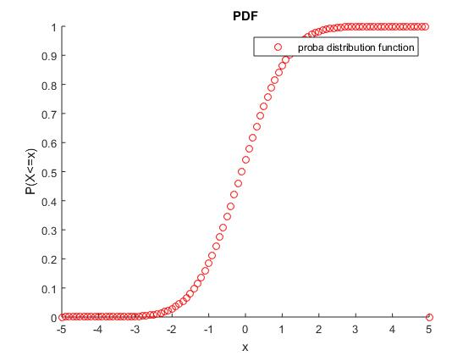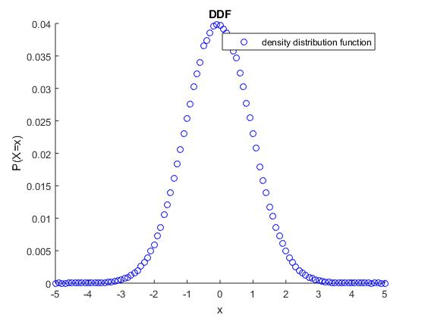

The method of reject in simulation of normal distribution (Code in [Annex 2])
The result of 1 million iterations: E(X) = 2.1396e-04 = 0; Var(X) = 1.0000
But in new experiments it gives the same precision as Polar method.
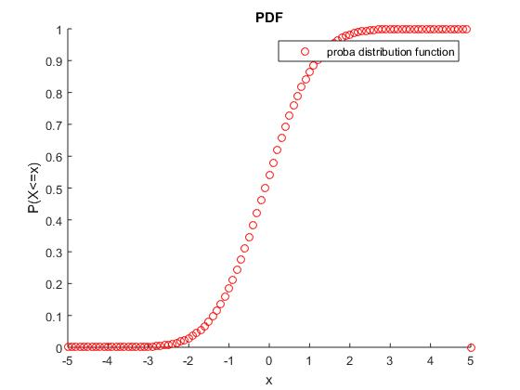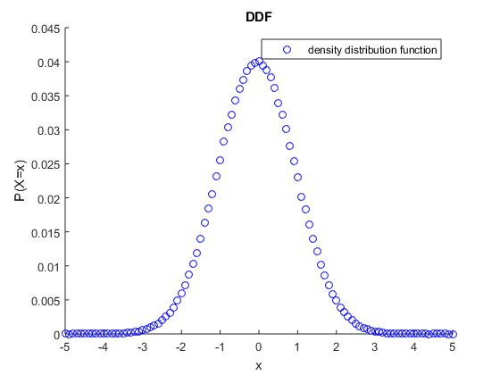

TCL method in simulation of normal distribution (Code in [Annex 3])
The result of 100000 iterations: E(X) = 0.2955; Var(X) = 0.9981
We had to do less iterations as this method is much slower than two other.
The reason for this – 1000 of additional operations on every iteration (as method assumes simulating random numbers to obtain their arithmetic mean).
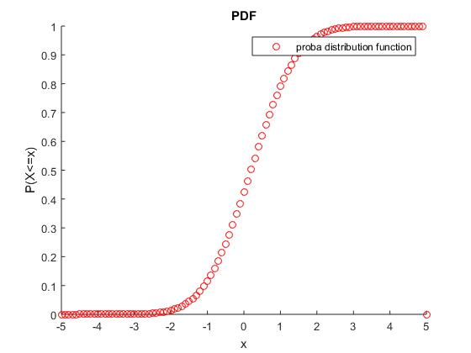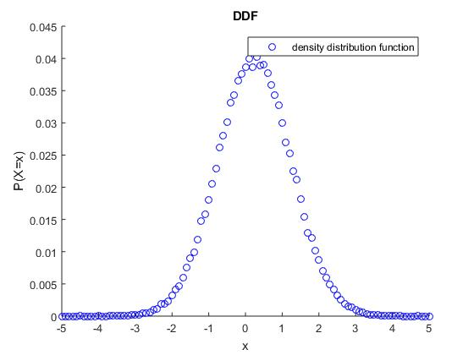

Simulation of the Brownian Motion: Random walk and Gaussians (Code in [Annex 4])
1st method: Random walk (multiple trajectories)
Initial data: T = 10; Discretization of t = 500; Ϝ₀ = {W0 = W(1) = 0}; Number of trajectories = 100;
Results for t = T = 10: E(W₁₀|Ϝ₀) = 0.5171 (theoretical = T = W₀ = 0) ; Var(W₁₀|Ϝ₀) = 10.4277 (theoretical = T =10)

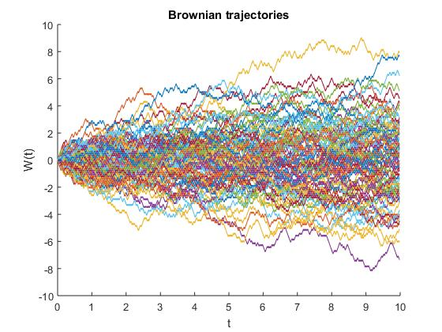
2nd method: Gaussians

2.1 Polar coordinates:
Initial data: T = 10; Discretization of t = 500; Ϝ₀ = {W0 = W(1) = 0}; Number of trajectories = 100;
Results for t = T = 10: E(W₁₀|Ϝ₀) = -0.0777 (theoretical = T = W₀ = 0) ; Var(W₁₀|Ϝ₀) = 9.3131 (theoretical = T =10)

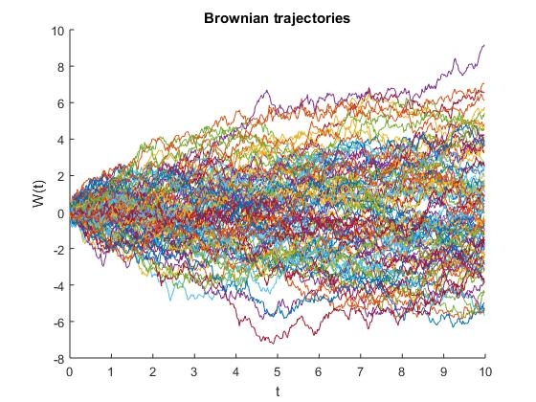

2.2 Reject method
Initial data: T = 10; Discretization of t = 500; Ϝ₀ = {W0 = W(1) = 0}; Number of trajectories = 100;
Results for t = T = 10: E(W₁₀|Ϝ₀) = -0.1380 (theoretical = T = W₀ = 0) ; Var(W₁₀|Ϝ₀) = 8.7037 (theoretical = T =10)

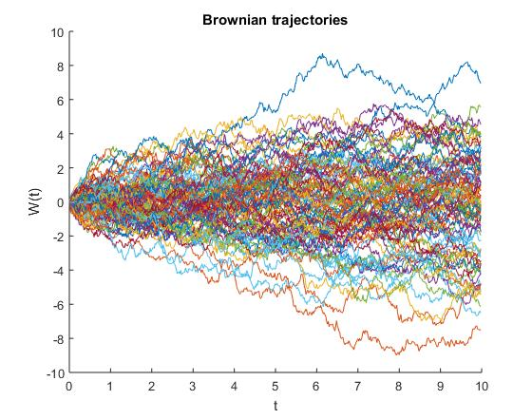
2.3 TCL method
Initial data: T = 10; Discretization of t = 500; Ϝ₀ = {W0 = W(1) = 0}; Number of trajectories = 100;
Results for t = T = 10: E(W₁₀|Ϝ₀) = -0.1123 (theoretical = T = W₀ = 0) ; Var(W₁₀|Ϝ₀) = 9.1784 (theoretical = T =10)
+ Slower execution
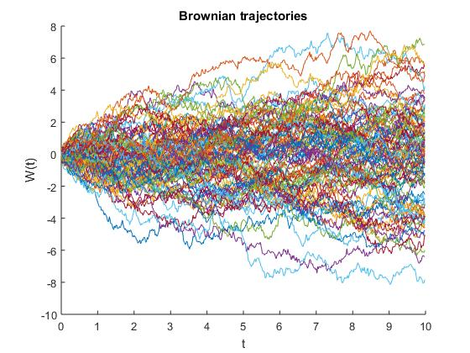

Comparison of 4 trajectories:
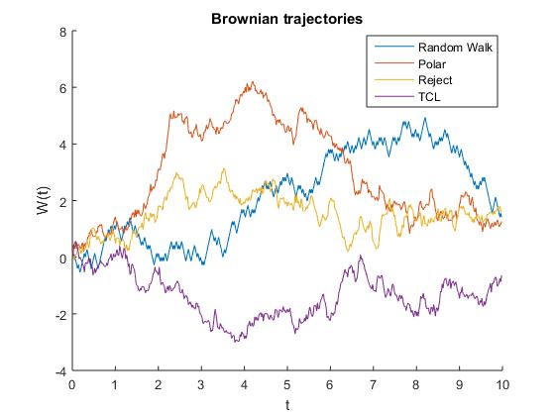
Related models simulation

Geometric Brownian Motion (Asset price simulation): (Code in [Annex 5])
Underlying functions: BMsimulator, Normal_polar
Initial data: S0 = 10; mu = 0.1; sigma = 0.5; T = 0.5; delta_t = 0.005;

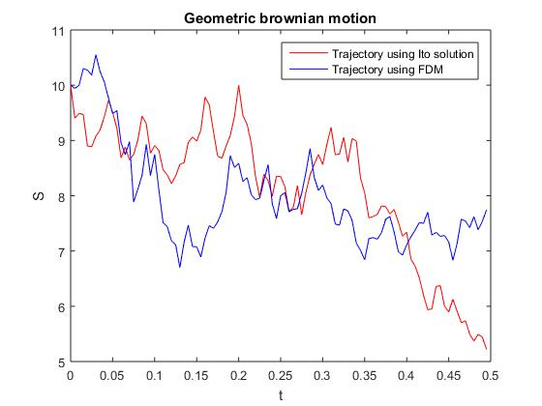

Ornstein-Ulenbeck (Interest rate simulation): (Code in [Annex 6])
Underlying functions: BMsimulator, Normal_polar
Initial data: R0 = 0.2; a = 0.3; b = 0.8; sigma = 0.2; T = 5; delta_t = 0.005;

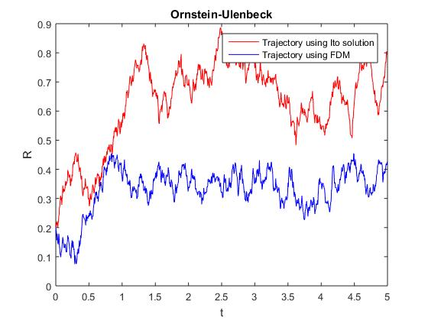

ANNEX 1 : Method of Polar Coordinates

function [alpha] = normal_polar(num_of_iter,mu,sigma)

%% Generating of U,Y - independent r.v
k = 1;
while k <= num_of_iter

V1 = 2*rand()-1;
V2 = 2*rand()-1;
S = V1^2 + V2^2;

if S < 1
alpha(k) = V1*(-2*log(S)/S)^(1/2);
alpha(k) = alpha(k)*sigma + mu;
k = k+1;
end;

end;

return;

ANNEX 2 : Reject method

function [alpha] = normal_reject(theta,num_of_iter,mu,sigma)

%% Generating of U,Y - independent r.v
k = 1;
while k <= num_of_iter

Y(k) = log(abs(1-rand()))/(-theta); % Formula for exponential distribution
u(k) = rand();

if u(k)<=exp(-((Y(k)-1)^2)/2)
if rand()<0.5
alpha(k) = Y(k);
else
alpha(k) = -Y(k);
end;

Y(k) = Y(k)*sigma + mu;
k = k+1;
end;

end;

return;

ANNEX 3: TCL method

function[alpha] = normal_TCL(num_of_iter, mu, sigma)

%% Definition of loops' size

num_of_rand = 10000;

%% Main program

for k = 1:num_of_iter

Arithmeticmean_ubar = mean(rand(num_of_rand,1)); % Calculating of arithmetic mean
alpha(k) = (Arithmeticmean_ubar-0.5)*(12*num_of_rand)^(0.5)*sigma + mu; % Looking for alpha non-centered

end;

return;

ANNEX 4: Simulator of Brownian Motion

function[W] = BMsimulator(T,discretization_num_t,method)

delta_t = T/discretization_num_t;
t(1) = 0;
for q = 2:discretization_num_t
t(q) = t(q-1) + delta_t;
end;

if (strcmp(method,'TCL'))

W(1) = 0;

gaussian = normal_TCL(discretization_num_t,0,1);

for i = 2:discretization_num_t

W(i) = sqrt(delta_t)*sum(gaussian(1:i));
% W(i) = sqrt(t(i))*sum(gaussian(1:i))/sqrt(i);

end;

elseif (strcmp(method,'Reject'))

W(1) = 0;

gaussian = normal_reject(1,discretization_num_t,0,1);

for i = 2:discretization_num_t

% W(i) = sqrt(delta_t)*sum(gaussian(1:i));
W(i) = sqrt(t(i))*sum(gaussian(1:i))/sqrt(i);

end;

elseif (strcmp(method,'Polar'))

W(1) = 0;

gaussian = normal_polar(discretization_num_t,0,1);

for i = 2:discretization_num_t

W(i) = sqrt(delta_t)*sum(gaussian(1:i));
% W(i) = sqrt(t(i))*sum(gaussian(1:i))/sqrt(i);

end;

elseif (strcmp(method,'Random walk'))

W(1) = 0;
r = rand();
x(1) = (r>0.5)*(-1)+(r<=0.5)*(1);
for i = 2:discretization_num_t

if rand()>0.5
x(i) = -1;
else
x(i) = 1;
end;

W(i) = sqrt(t(i))*sum(x(1:i))/sqrt(i);
% W(i) = sqrt(t(i))*sum(gaussian(1:i))/sqrt(i);

end;

end;

return;

ANNEX 5: Geometric Brownian Motion

Using ITO exact solution (function returns a path)
function [S] = GBM_ITOSimulator(S0,mu,sigma,T,delta_t)

discretization_num_t = T/delta_t;

t(1) = 0;
for i = 2:discretization_num_t
t(i) = t(i-1)+delta_t;
end;

W = BMsimulator(T,discretization_num_t,'Polar');
S(1) = S0;
for i = 2:discretization_num_t
S(i) = S(1)*exp((mu-sigma^2/2)*t(i)+sigma*W(i));
end;

return;

Using FDM (function returns a path)
function [S] = GBM_FDMSimulator(S0,mu,sigma,T,delta_t)

discretization_num_t = T/delta_t;

t(1) = 0;
for i = 2:discretization_num_t
t(i) = t(i-1)+delta_t;
end;

W = BMsimulator(T,discretization_num_t,'Polar');
S(1) = S0;
for i = 2:discretization_num_t
S(i) = S(i-1) + S(i-1)*((mu-sigma^2/2)*delta_t+sigma*(W(i)-W(i-1)));
end;

return;

Proof of the concept
clear; clc;

S0 = 10;
mu = 0.1;
sigma = 0.5;
T = 0.5;
delta_t = 0.005;

discretization_num_t = T/delta_t;

t(1) = 0;
for i = 2:discretization_num_t
t(i) = t(i-1)+delta_t;
end;

S = GBM_ITOSimulator(S0,mu,sigma,T,delta_t);
S2 = GBM_FDMSimulator(S0,mu,sigma,T,delta_t);

plot(t,S,'r');
hold on;
plot(t,S2,'b');
xlabel('t'); ylabel('S');
title('Geometric brownian motion')
legend('Trajectory using Ito solution', 'Trajectory using FDM');

ANNEX 6: Ornstein-Ulenbeck model

Using ITO exact solution (function returns a path)
function [R] = Ornstein_ITOSimulator(R0,a,b,sigma,T,delta_t)

discretization_num_t = T/delta_t;

t(1) = 0;
for i = 2:discretization_num_t
t(i) = t(i-1)+delta_t;
end;

W = BMsimulator(T,discretization_num_t,'Polar');
R(1) = R0;
for i = 2:discretization_num_t

for s = 2:i
integral(s) = exp(a*(t(s)-t(i)))*(W(s)-W(s-1));
end;
R(i) = R(1)*exp(-a*t(i))+b*(1-exp(-a*t(i)))+sigma*sum(integral);
end;

return;

Using FDM (function returns a path)
function [R] = Ornstein_FDMSimulator(R0,a,b,sigma,T,delta_t)

discretization_num_t = T/delta_t;

t(1) = 0;
for i = 2:discretization_num_t
t(i) = t(i-1)+delta_t;
end;

W = BMsimulator(T,discretization_num_t,'Polar');
R(1) = R0;
for i = 2:discretization_num_t
R(i) = R(i-1) + a*(b-R(i-1))*delta_t + sigma*(W(i)-W(i-1));
end;

return;

Proof of the concept
clear; clc;

R0 = 0.2;
a = 0.3;
b = 0.8;
sigma = 0.2;
T = 5;
delta_t = 0.005;

discretization_num_t = T/delta_t;

t(1) = 0;
for i = 2:discretization_num_t
t(i) = t(i-1)+delta_t;
end;

R = Ornstein_ITOSimulator(R0,a,b,sigma,T,delta_t);
R2 = Ornstein_FDMSimulator(R0,a,b,sigma,T,delta_t);

plot(t,R,'r');
hold on;
plot(t,R2,'b');
xlabel('t'); ylabel('R');
title('Ornstein-Ulenbeck')
legend('Trajectory using Ito solution', 'Trajectory using FDM');

